Project design Phase
Solution Architecture

Date | 29-06-2026
Project Name | Automated Network Request Management
Team ID
Maximum Marks

Solution Architecture:
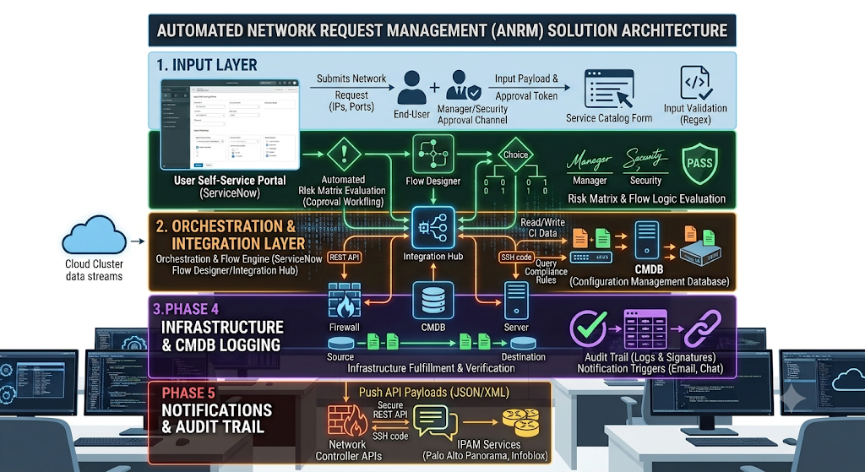

The proposed architecture leverages the ServiceNow (Now) Platform to bridge the gap between the end-user's need for network connectivity and the IT fulfillment process. The solution is centralized within the cloud-based ServiceNow environment, utilizing its built-in portal, database, and automation engine to deliver a seamless experience.

